





APPENDIX VII

LESSON PLAN TEMPLATE
Lesson Plan No: 4
Name of the student-teacher: Dorji Khandu.
Class: 8 Period: 1st Subject: ICT
Previous Knowledge of the students: Students are proficient in inserting multimedia elements (images, video, and audio) into MS PowerPoint slides. They understand the basic "Insert" tab functions.
Teaching skills/Method: Demonstration and Hands-on Practice.
Teaching learning materials: (Monitor, Google Accounts for each student, Projector and Screen for teacher demonstration, Guided worksheet with step-by-step instructions in google classroom.)
Computers with MS PowerPoint, Projector and Screen, a pre-made "Static" presentation that the PPT with multimedia of last class (but no effects).
Lesson objectives  By the end of the lesson, the student should be able to: | Assessment  (How are you going to know if the lesson objectives have been achieved? What will you do to find out? What assessment techniques or tools are you going to use?)
Cognitive:  Define animation and transition;  Distinguish between a "Transition" and an "Animation”; | Oral Questioning:  Ask students to identify which tab to use for moving an entire slide vs. moving a single image.
Psychomotor:  Apply three transition effect to a slide and two different animation effects to objects; | Performance Task:  Monitor students as they add effects to their "Multimedia Slide" from the previous lesson.
Affective:  Appreciate three importance of using subtle visual effects to enhance presentation clarity | Observation: Check if students choose media that matches their slide topic and cite their sources.
Teacher’s Activity | Learners’ Activity
Lesson Introduction:(Gaining attention, prior knowledge, lesson outline and lesson objective)  8 mins  Good morning, everyone! How is the energy in the room today?  Glad to hear it. Is the ICT lab feeling a bit chilly, or is it just me?  Could everyone turn to the projector, please?  Now are you all felling comfortable.  Please remember ICT lab rules and refrain from touching anything until and unless teacher permits.  Well, let's warm up our brains! Before we start our today’s lesson.  Think for 1 minute. What is the lesson did we covered in our last class.  Okay think time done.  Can I have any volunteer?  Does anyone have a different answer?  Yes, exactly thank you for participating. Let’s appreciate the volunteers. Give them a silent clap.  Last class, we made our slides look great with pictures and videos. But today, we are going to make them move.  Have you ever seen a presentation where the slides just... pop? Or an image flies into the screen? (T–WC)  Displaying my PPT  Showing topic with bold text.  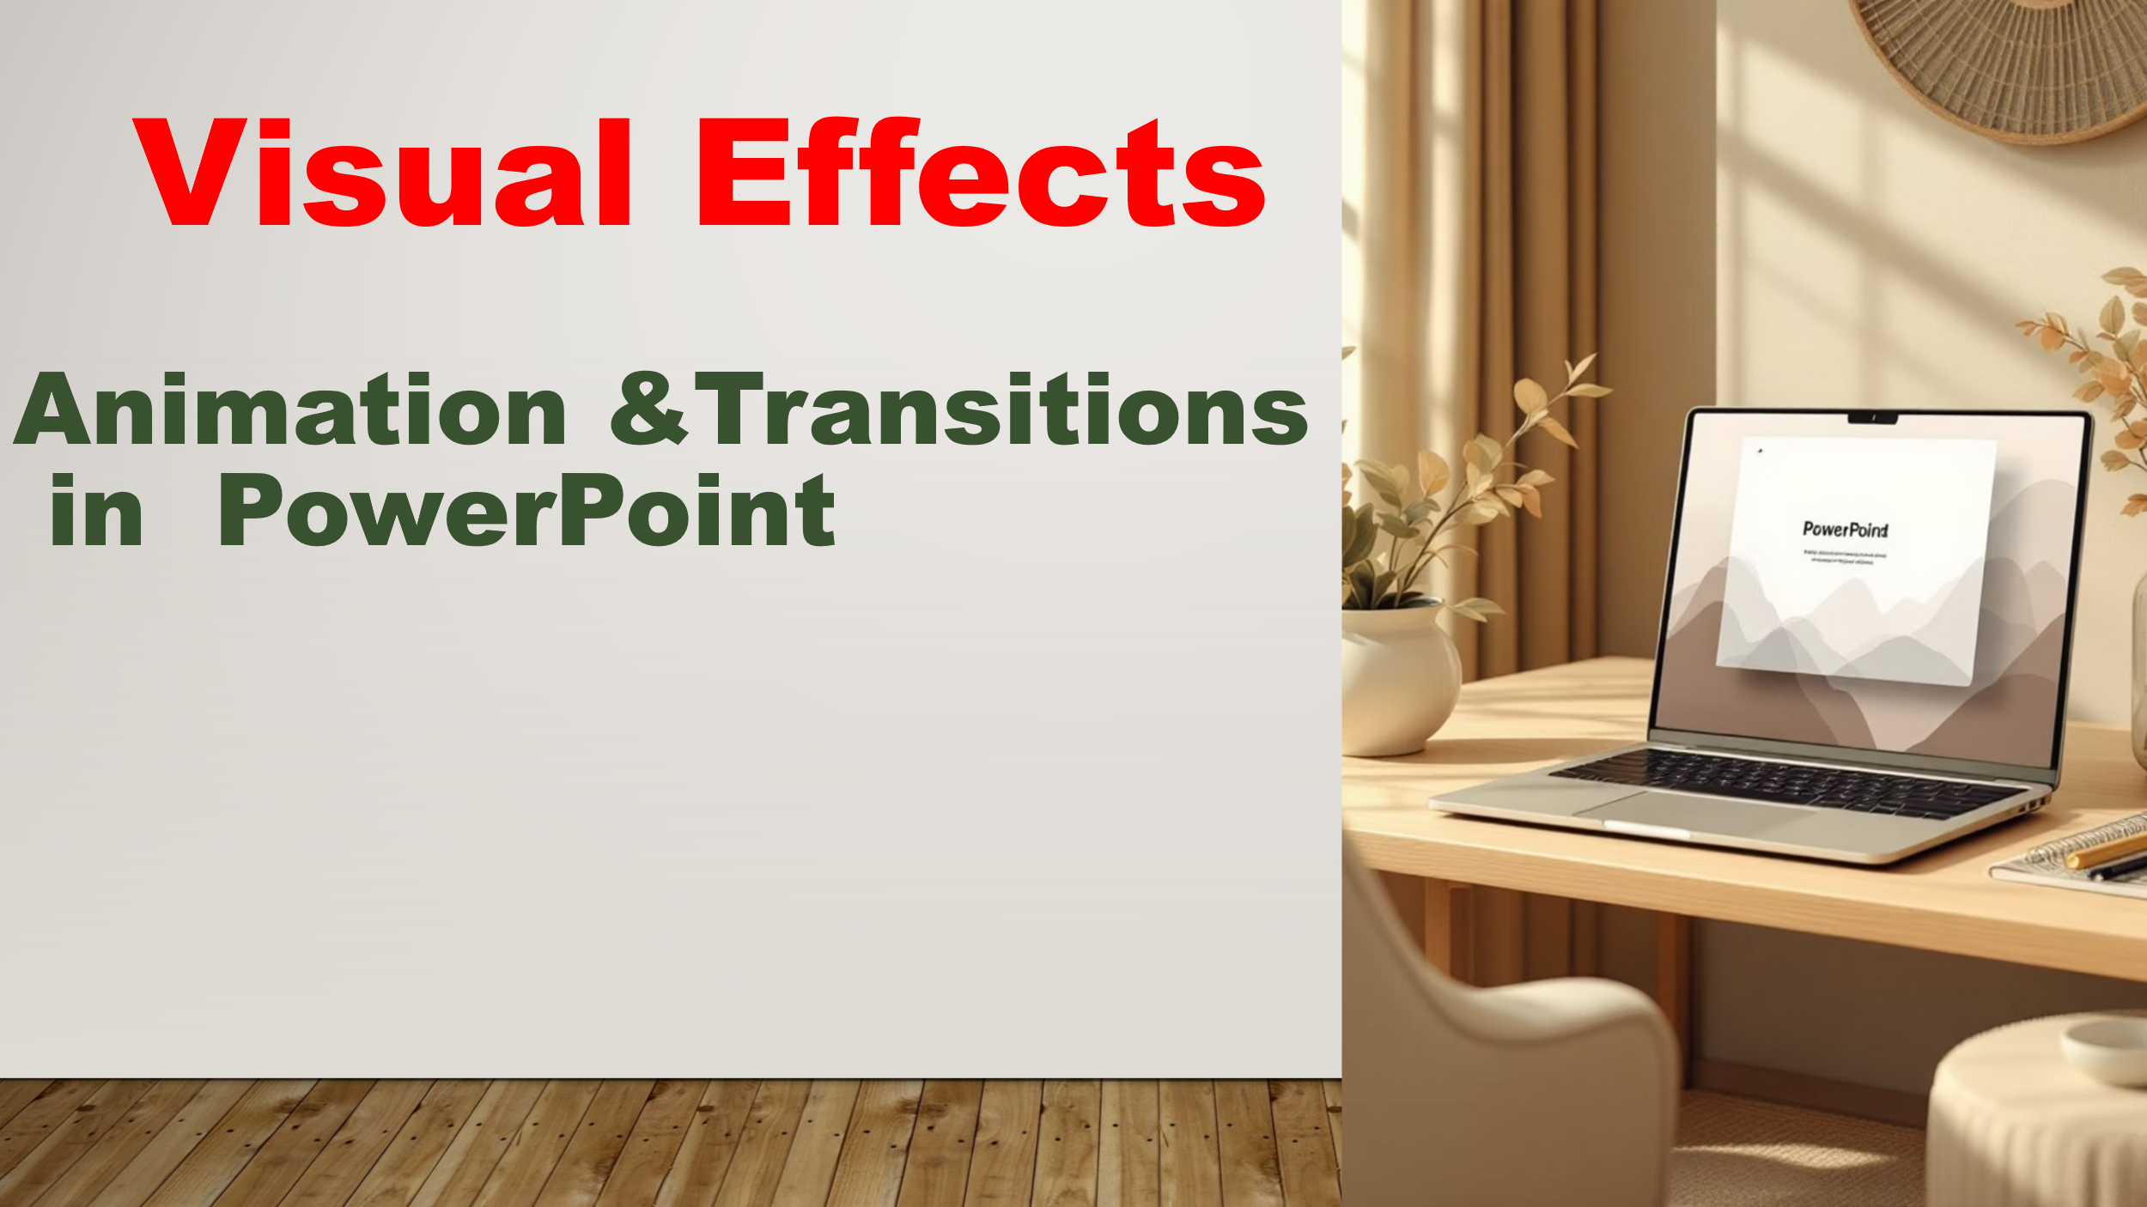  Exactly. Today we learn Visual Effects and it includes Transitions and Animations.  Showing lesson objectives  So, by the end of the lesson,  Lesson Objectives:  - Define and identify animation and transition;  - Distinguish between a "Transition" and an "Animation”;  - Apply three transition effect to a slide and two animation effects to objects;  - Three importance of using subtle visual effects to enhance presentation clarity. | Good morning, sir, well sir.  It's cold today, sir.  Turning  Yes sir.  Active listening  Thinking  (adding multimedia……)  One or two more volunteers  Clapping silently  Active listening.  Yes, sir! It looks like a movie.  Google slide is online/web base where it saves the presentation automatically and MS PPT is desktop application.  Active listening  Active listening  Active listening
Lesson Development: (Gaining attention, teacher’s information input, activity instruction, checking instruction, monitoring, follow-up and assessment)  22 mins  “Hocus-pocus”.  Eyes on the screen, please.  Are we on same track?  Okay let me check.  On the count of three, everyone will say “WE ARE READY”  1….2….3…  Class what’s the main difference between transition and animation.  Any volunteers? If not don’t worry I will pick someone. (saying with smile)  Thank you for sharing and let do silent clap for him/her.  There is a golden rule in PPT: Transitions are for the whole slide. Animations are for the things on the slide.  Transition is slide-to-slide effect like Fade or Push, applied once per slide to control flow between pages.  Animation is adding movement or special effects on individual objects like text, shapes, images.  Is that clear? Or do I need to go over again?  Display next slide with a slow transition including all the messy animation order for all elements.    Here what do you notice with this slide and what might it tell us?  Or nothing at all?  Yes, perfectly thank you for volunteering (in appreciating tone)  Avoid these common mistakes with animation and transition.  Display next slide  Here first mistake is  Overloading Objects  Too many animations per slide confuses viewers and reduce your message.  Second is  Inconsistent Transitions  Switching between Fade, Push, and Zoom within the same section breaks visual tempo and professionalism.  So, do animations and transitions need to be used carefully? (in loud voice)  People at the back don’t you think we should use animations and transitions carefully to avoid distracting the audience?  Please raise your voice  Just as a coin has two sides, we have best practices to avoid common mistakes.  I will show next slide  Best practices are number 1 we have  Keep It Simple to make the transition style across the entire slide for consistent visual tempo.  Second  Purpose-First Design. Every animation must answer: "What does the audience need to notice?" If unclear, remove it.  Next, we have Timing  Is timing Matters?  Why?  Exactly because to create smooth flow between slide and animation making presentation more cohesive and to avoid distraction.  By default, speed is 0.5 seconds and it is best option to use.  Is everything clear up to this point?  So, does that mean everything is clear?  Alright, if there are no questions, who would like to recap what we’ve covered?  Excellent, thank you for your participation.  Please listen and follow each steps carefully. Feel free to ask any questions you have along the way.  Open your presentation that we made in last class  Demonstration (Steps):  Adding Slide Transitions  - Transitions are the visual effects that occur when you move from one slide to the next.  - Select the Slide: In the thumbnail pane on the left, click on the slide you want to add a transition to.  - Open the Transitions Tab: Click the Transitions tab on the top ribbon.  - Choose an Effect: Click the More arrow in the transition gallery to see all options.  - Adjust Effect Options: Click Effect Options (next to the gallery) to change the direction (e.g., from Right, from Top).  - Set the Timing: In the Timing group, you can change the Duration to make the movement faster or slower.  - Apply to All: If you want every slide to move the same way, click Apply to All.  Adding Object Animations  - Select the Object: You must first click on the specific Image or Text Box you want to move.  - Open the Animations Tab: Click the Animations tab on the top ribbon.  - Choose an Entrance Effect: Click the More arrow in the gallery and select a green icon (Entrance).  - Use the Animation Pane: Click Animation Pane to see a list of all movements on the slide. You can drag them to change the order.  - Preview: Click the Preview button on the far left of the ribbon to see your work in action.  Are you all manage to get these steps working in your presentation as we go along.  Now we have pair activity | Follow the teacher's demonstration on their own screens. Experiment with different themes and insert an image related to a chosen hobby.  “Everybody focusses”.  Yes sir.  Yes sir  1.2.3 (in loud voice)  (someone volunteers)  Concentrating  Yes sir, clear sir.  Active focusing  (Someone volunteers. Sir animations are very messy/ transition is too slow)  Active listening.  Active listening.  Yes sir.  Yes sir  Yes sir (loudly)  Active listening  Yes sir.  Because to avoid distraction.  Active listening.  Yes sir.  Yes sir.  (common mistakes, transition, animation and best practices).  Fine sir.  Following and concentrating.  Following and concentrating.  Yes, sir we are all done.
Lesson Closure: (Gaining attention, evaluation and extended learning)  10 mins  “Class! Class!”.  Before we pack up, let’s take a look at what we’ve achieved today.  We started the lesson with definition of transition and animation.  Who can tell me the definition of Transition and an Animation?  Pair Activity  Instructions:  - Turn to your shoulder partner and use one computer between the two of you.  - Discuss three differences between animation and transition.  - I will randomly select one pair to share your answer.  - 4 minutes to discuss your answer.  Are you all clear with instruction.  Monitoring  (Teacher moves around and sees what they are discussing)  Follow up Activity  which tab do I use to make my image 'Fly In'?.  Times up! Can we hear from each pair.  I will supplement points with the last slide  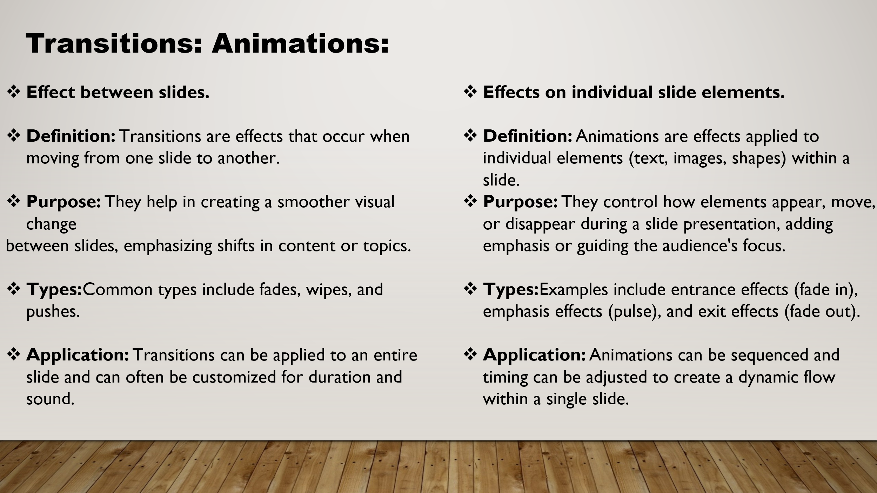  Is everyone clear?  Okay fine then.  Great job today, everyone. Please save your 'Hobby Slide' to your Google Drive or the class folder before logging off.  See you in the next class! | Practice sharing the document with a partner and save their work. Ask clarifying questions about the transition task.  Yes, yes.  Active listening.  (someone volunteers- Transitions is the movement between the whole slide when we change pages, but Animations refers to movement of the pictures or text inside the slide, sir!").  Active listening  yes sir.  (sharing differences)  Saving work and logging off.  Thank you, sir.

